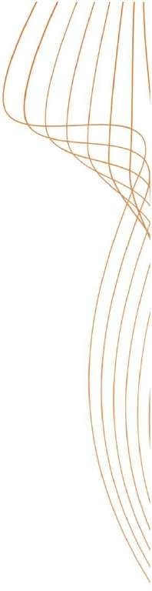

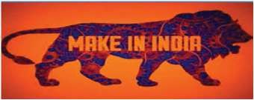

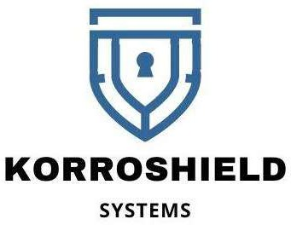

**CORROSION CONTROL EXPERTS**

**ABOUT US**

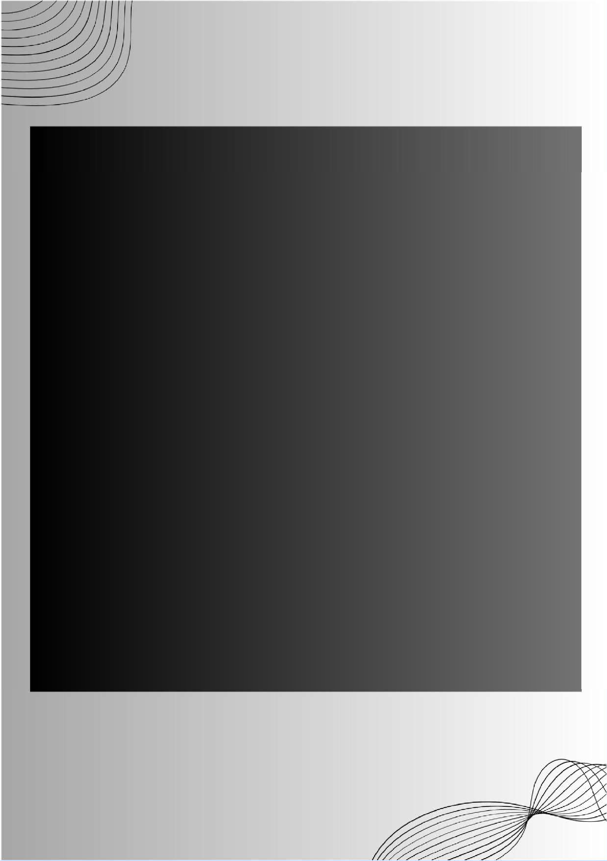

**Korroshield Systems** - Sole manufacturer of material in India.

Our company is led by a team of experienced technocrats, professionals, and retired senior government and public sector officials.

We specialize in conducting Corrosion Audits and providing solutions for corrosion protection and high- performance coatings to both private and public sector

organizations.

Our expertise lies in our extensive knowledge of products and systems,

enabling us to undertake research and development in new areas and to provide consultancy

and turnkey solutions for various types of anti- corrosive and high-performance coating solutions.

Additionally, we manufacture and source anti- corrosive products according to the specific requirements of our clients.

**SIMPLE STRONG DEPENDABLE**

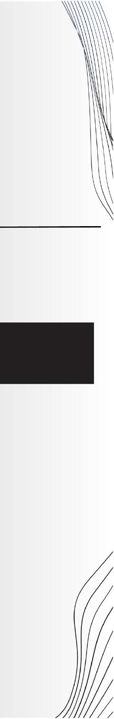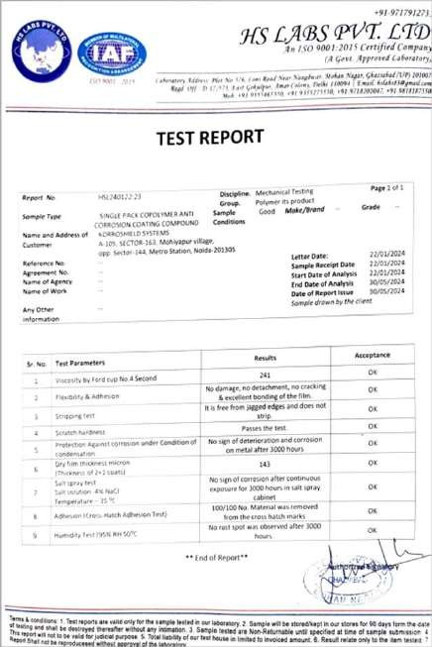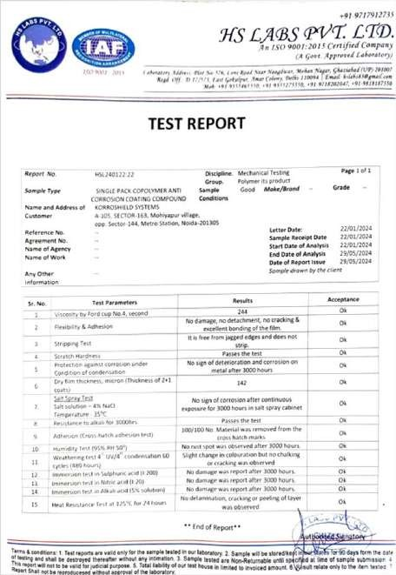

**KORROSHIELD RANGE OF PRODUCTS**

**1 2 3 4**



**KORR - 01 KORR-02 KORR – 03 KORR - 04**

**OUR PRODUCTS APPROVED BY**

# G O V T . A P P R O V E D T E S T I N G L A B O R A T O R Y

**NABL REPORTS**

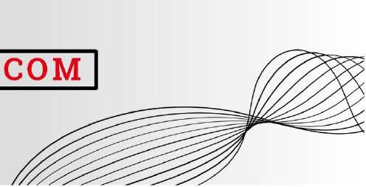

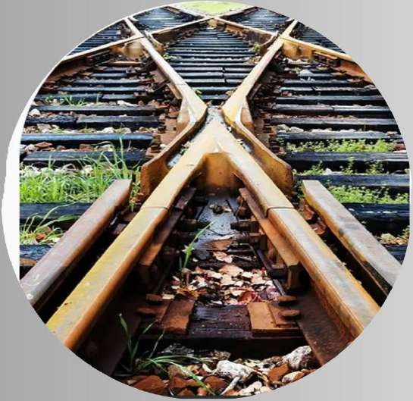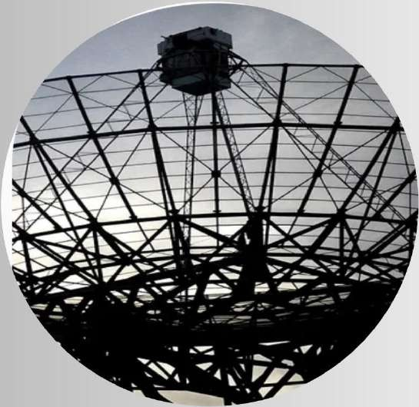

## PEC IALIS AT IO N

**O UR S**

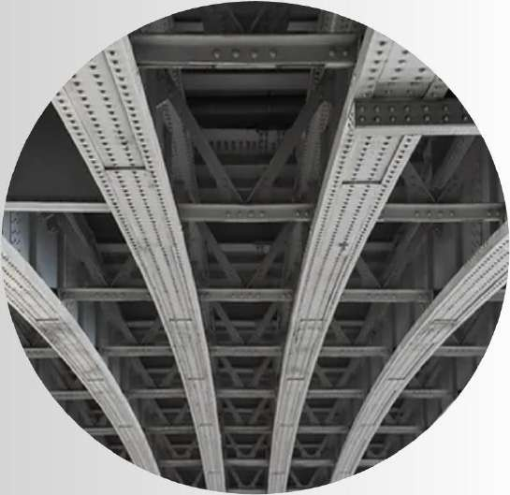

**RAI L TRAC K**

**BRI DG ES & C O RRI DO R**

**S I G NAL & TELEC O M**

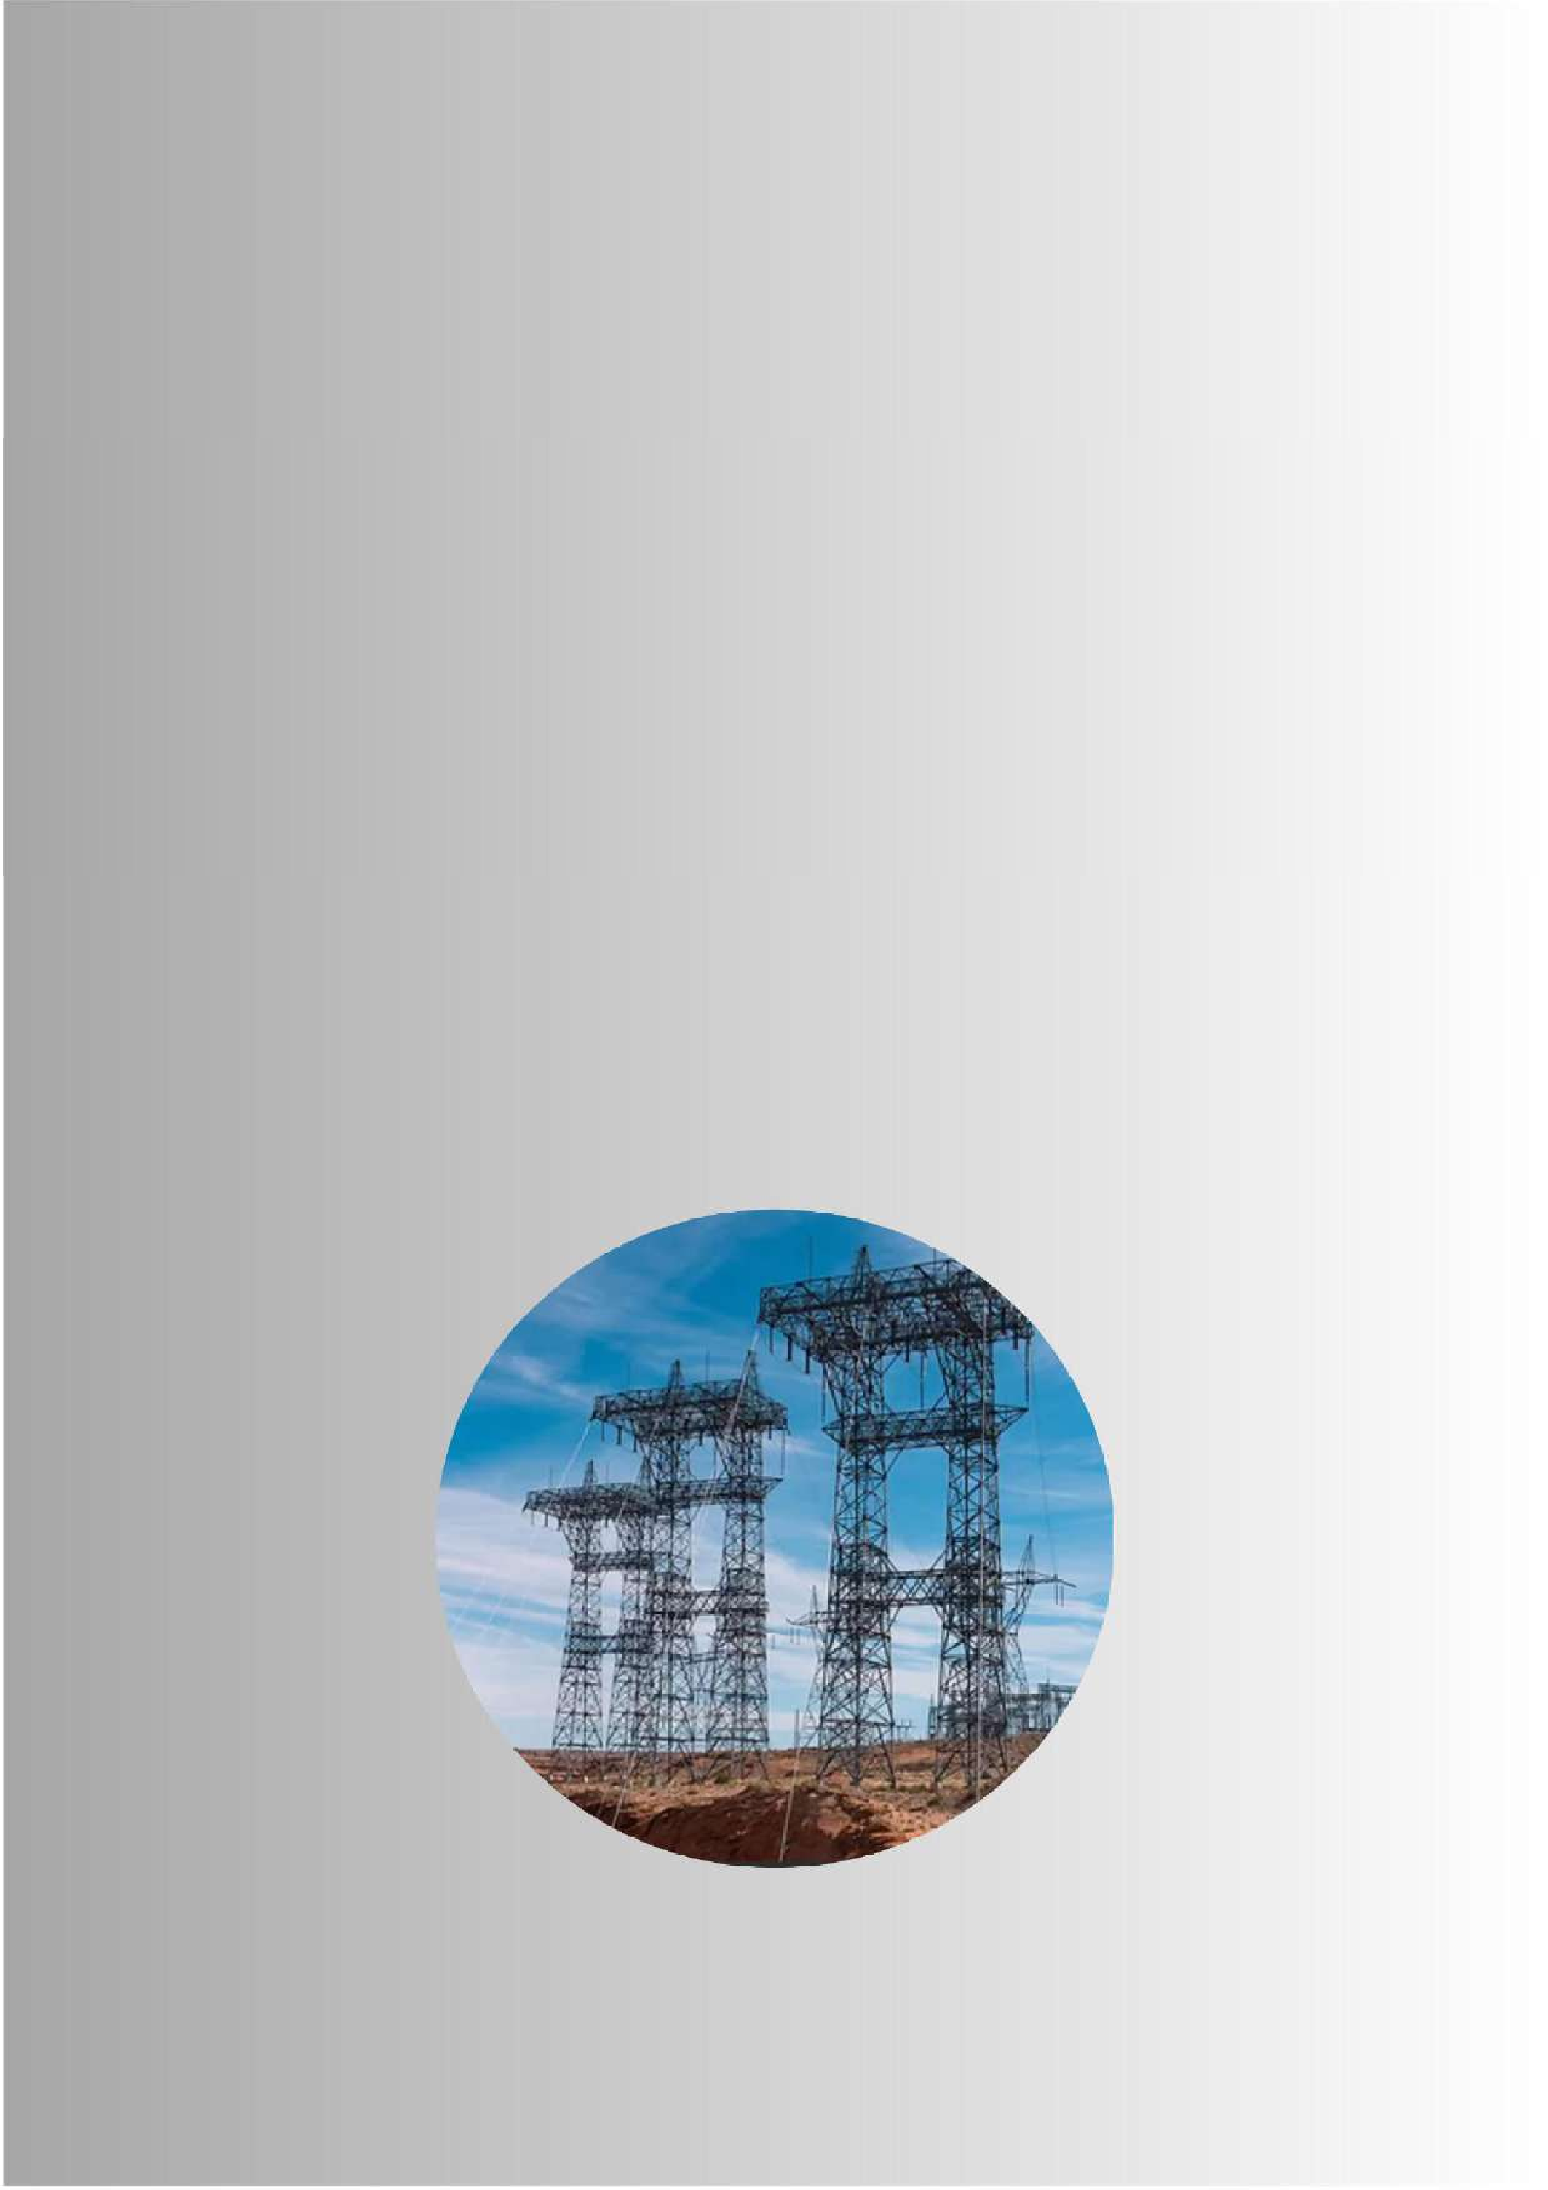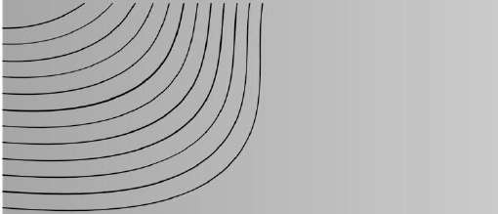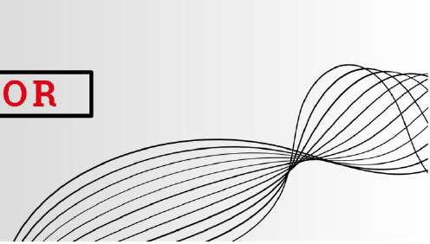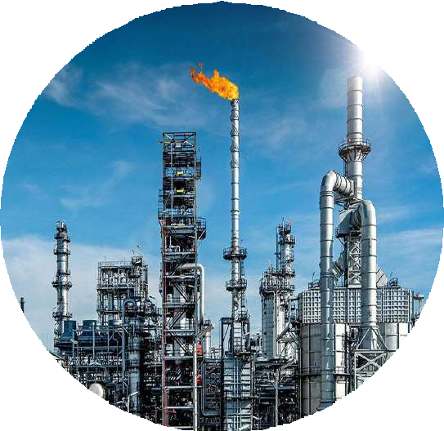

**O I L & G AS S EC TO R**

**PO WER S EC T**

**O R**

## METHOD OF APPLICATION



Remove the thick scales of rust on the metal surface with mild hammer strokes and clean out the surface thoroughly by scratching with metal shrapnel and steel-wire brushes. Then remove the loose rust particles on the metal surface by rubbing with dry cloth. Remove the stains of grease or oils, if any, on the metal surface by cleaning with kerosene or petrol. Make sure that the cleaned metal surface is completely dry before application. On the clean and dry metal surface, first give a coating of **KORR - 1**. After 24 hours apply One coat of **KORR - 2** (Primer) and allow to dry for one day. Then give two even coat of **KORR - 3** the Top Coat, some cases apply **KORR – 4** the Reflective top coat each coating at an interval of one day. Please note, our Products being Solvent- based, the first coating does not give a complete hiding of the lower surface. The final coating, however, produces a total hiding of the lower surface. While giving the coatings, do not unduly rub the brush for a long time over the same spot. This leads to the formation of plastic fibers on the brush which disturb the coating with the pulling effect. In fact, this is a peculiar property of **KORR - 4**. To avoid fibers, again take a little fresh material or thinner on the brush and make an even coating. The surface of the coating becomes tack-free within six hours and dries up completely within 24 hours.

Total hard drying through complete cross- linkages of the Co-polymer takes about a week. Please also shake/mix well before applying.



**KORR – 1, 2, 3**

**APPLICATION FOR HIGH TENSION**

**ELECTRICAL TOWER**

# PROCES

**S FLOW**

**N**

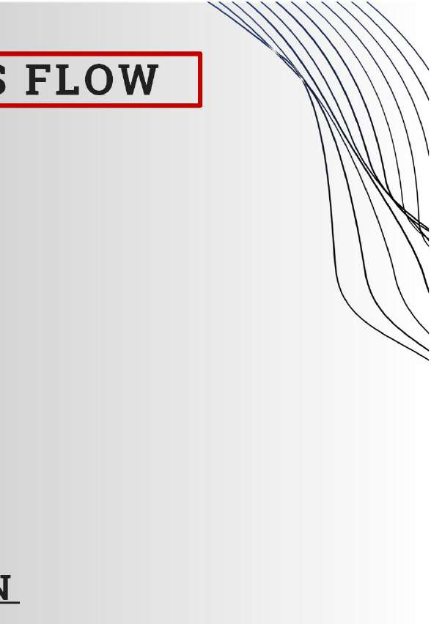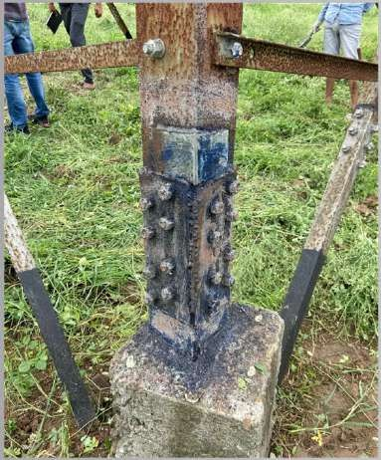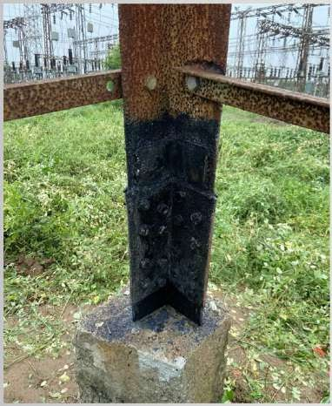

**REMOVAL OF RUST/PAINT DEPOSITS WITH HAND TOOLS**

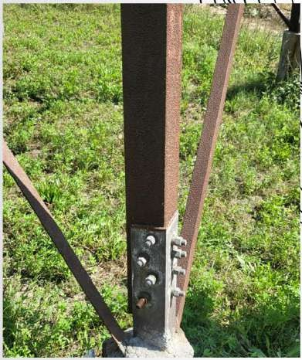

**BEFORE APPLICATION**

#### SURFACE PREPARATIO

* 1. Complete remove oil/grease from the metal surface by using petroleum hydrocarbon solvent to IS: 1745.
  2. Prepare the surface by sand or grit blasting to Sa 2-1/2 to IS: 9954 i.e. near white metallic surface.

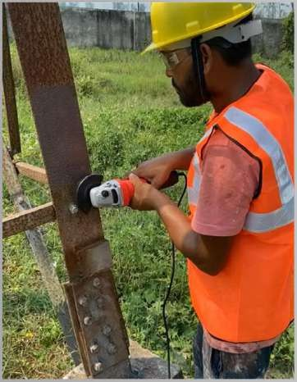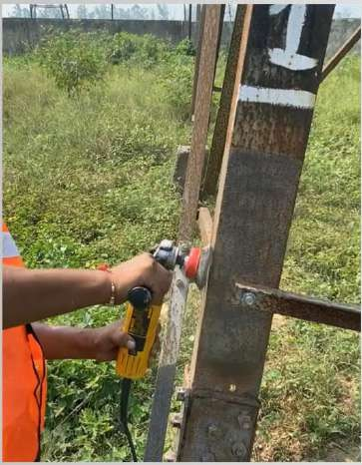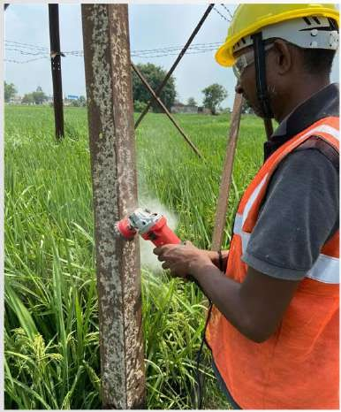

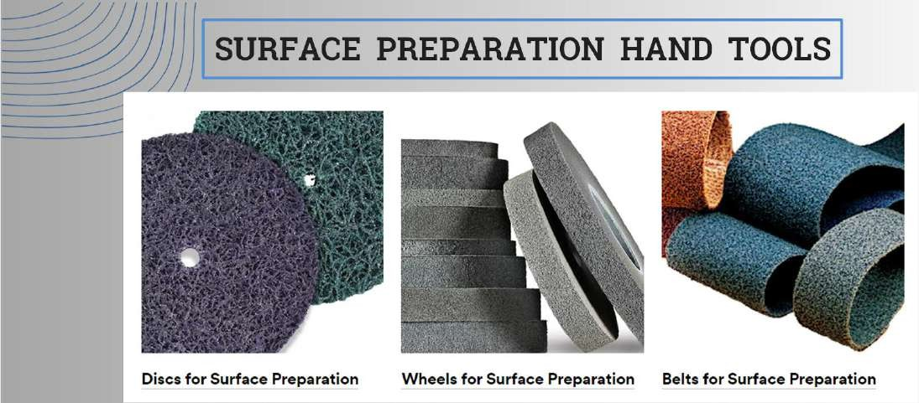**SURFACE PREPARATION HAND TOOLS**

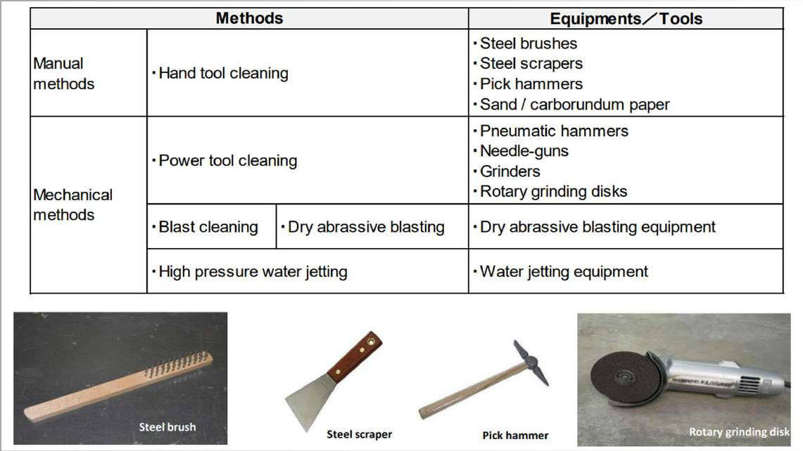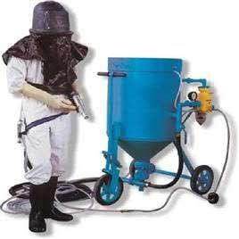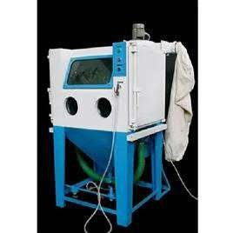

**M O B I L E S A N D B L A S T I N G M A C H I N E**

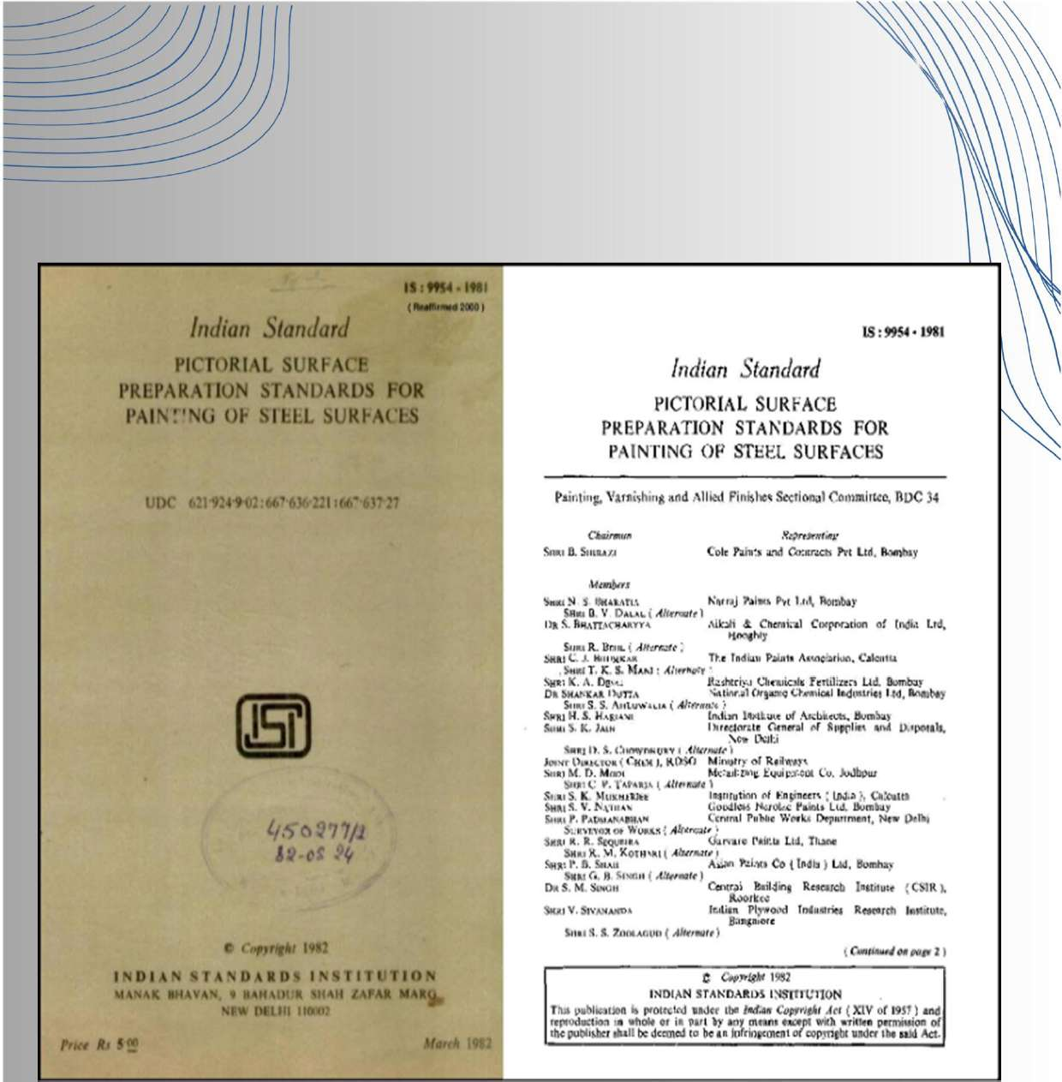

# STANDARD AS PER IS:9954 - 1981

#### APPLICATION OF KORR - 01 (1ST COAT)

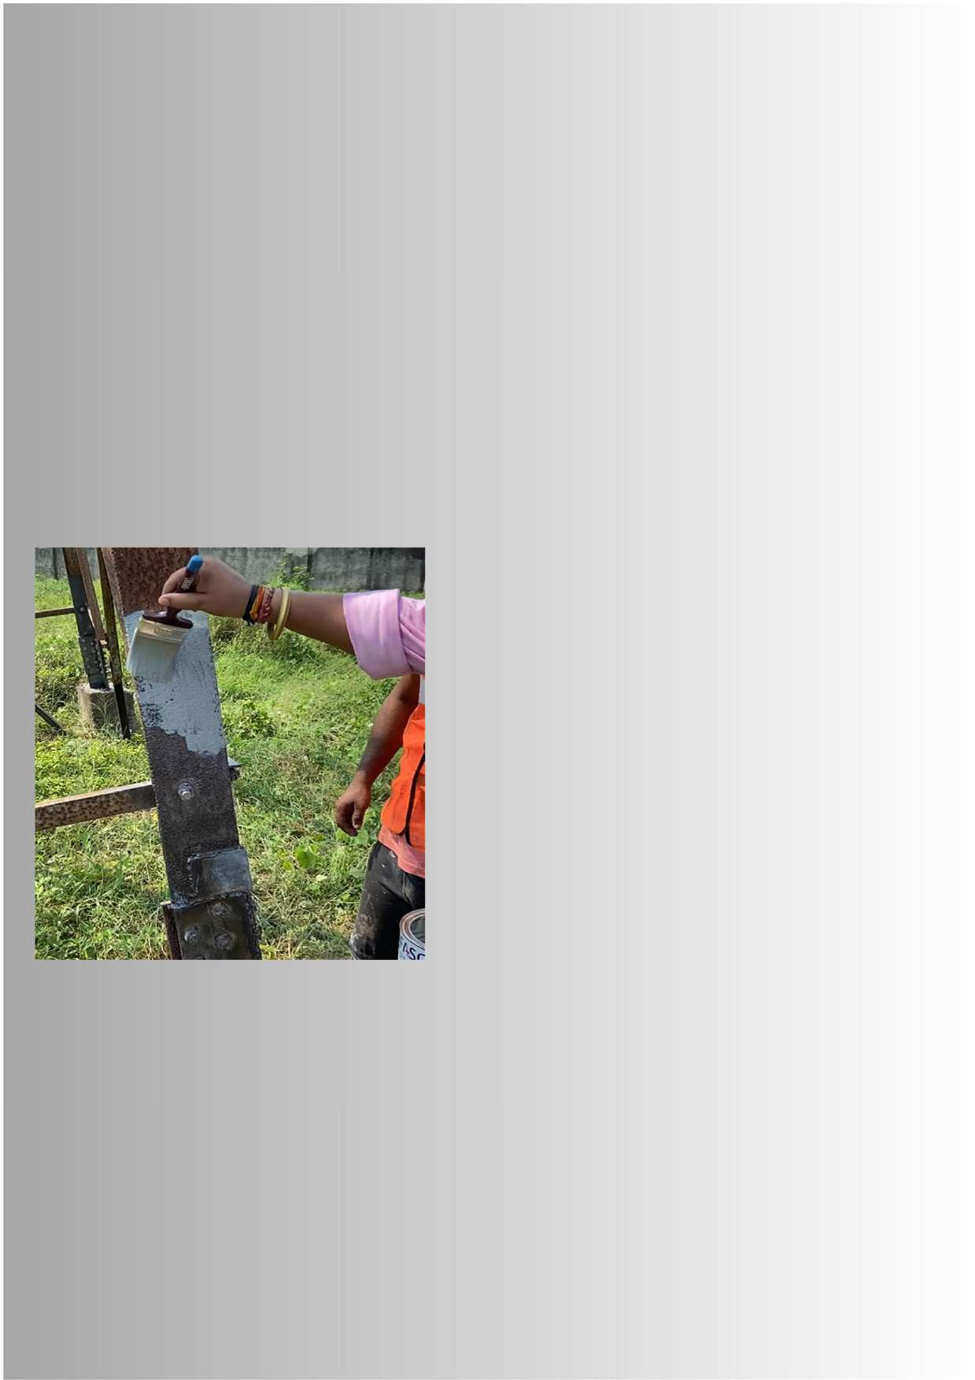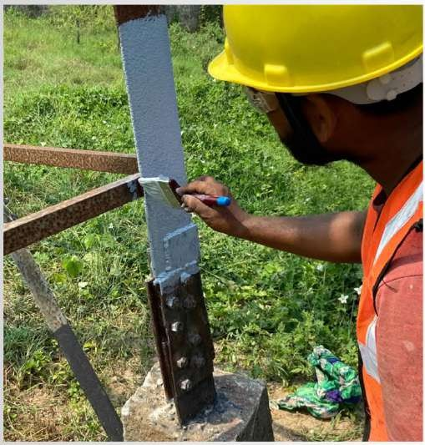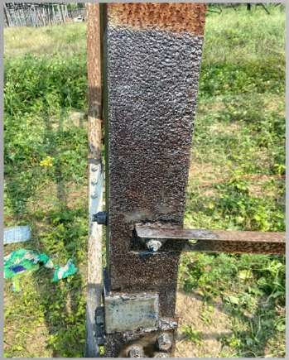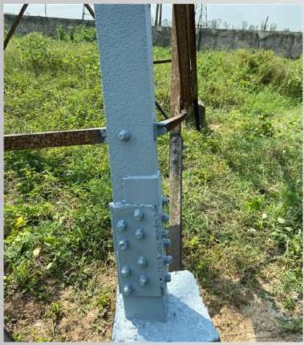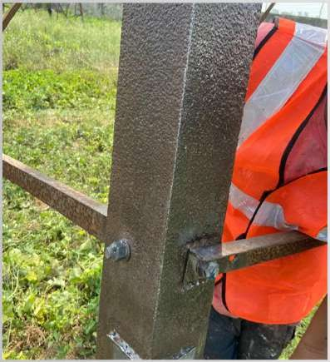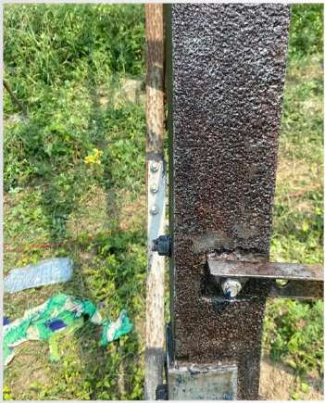

1. **APPLICATION OF KORR - 02 (2ND COAT)**



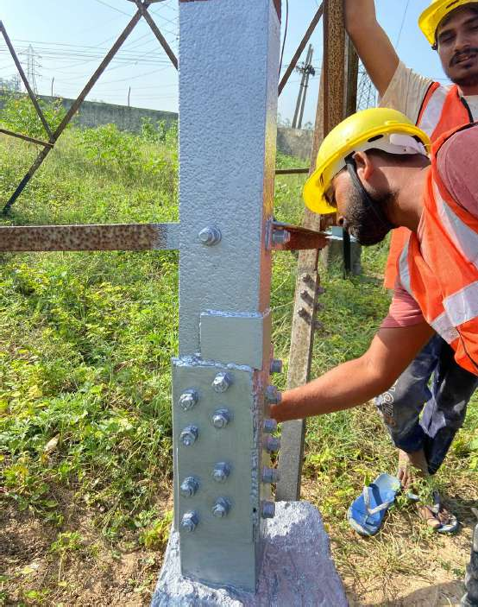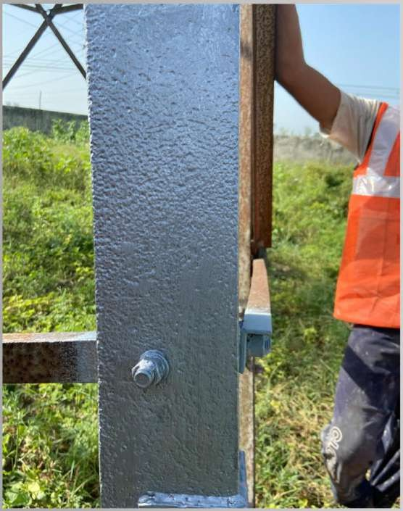

1. **APPLICATION OF KORR - 03 (TOP COAT)**

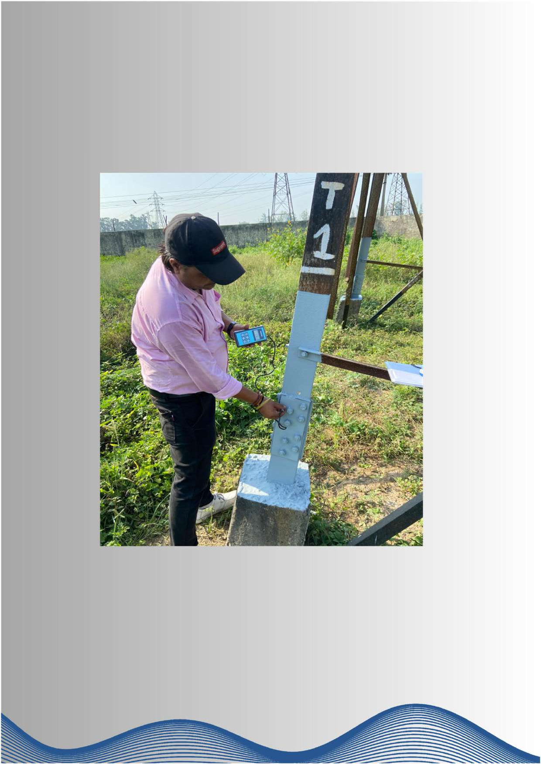

#### 4. FINAL INSPECTION AT SITE by QC Team

**I NS PEC TI O N by DFT METER**

**( DRY FI LM THI C KNESS METER)**



**KORR – 1, 2, 3**

**APPLICATION FOR**

**BRIDGES & CORRIDOR**

# PROCES

**S FLOW**

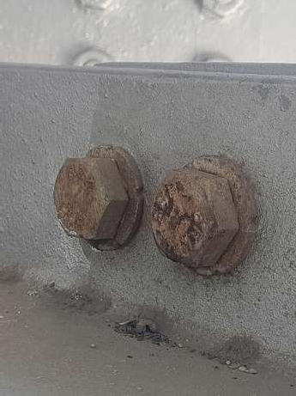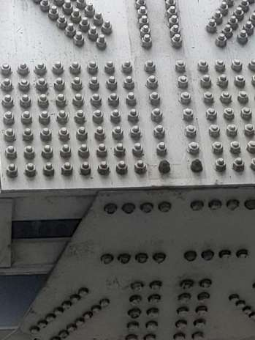

**REMOVAL OF RUST/PAINT DEPOSITS WITH HAND TOOLS**

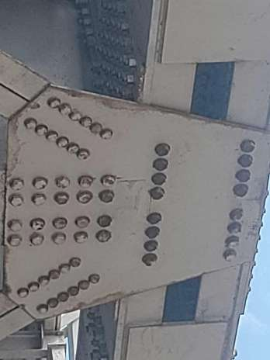

**BEFORE APPLICATION**

#### SURFACE PREPARATIO

* 1. Complete remove oil/grease from the metal surface by using petroleum hydrocarbon solvent to IS: 1745.

**N**

* 1. Prepare the surface by sand or grit blasting to Sa 2-1/2 to IS: 9954 i.e. near white metallic surface.

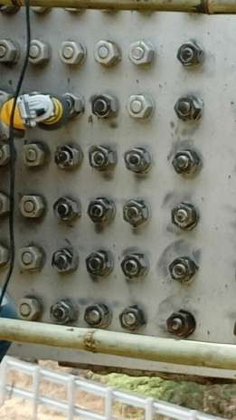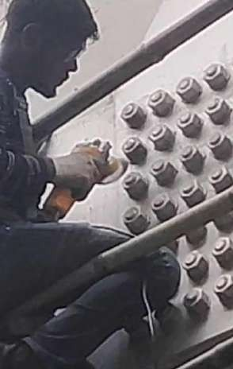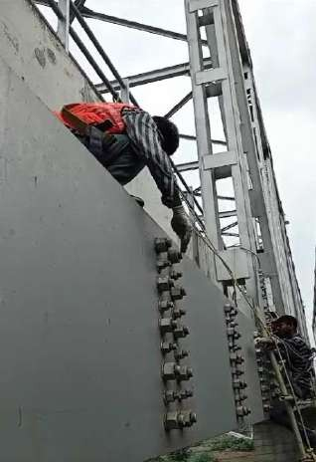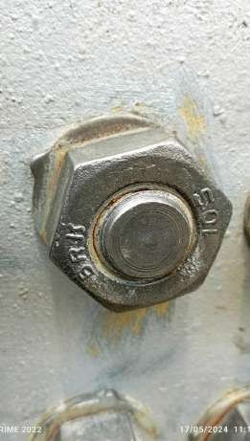

#### APPLICATION OF KORR - 1 (1ST COAT)

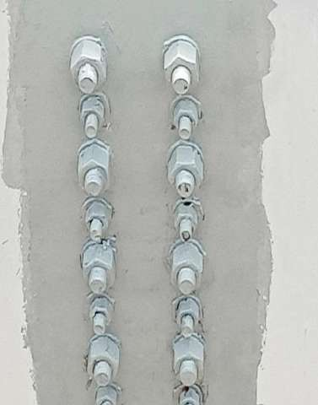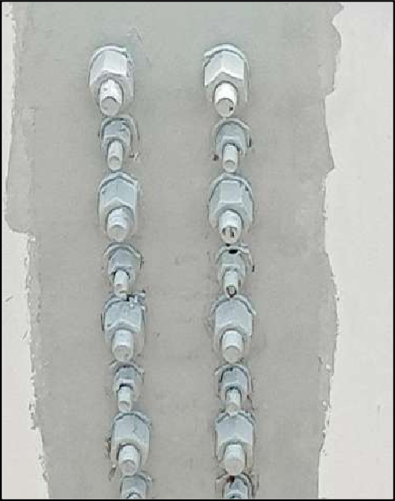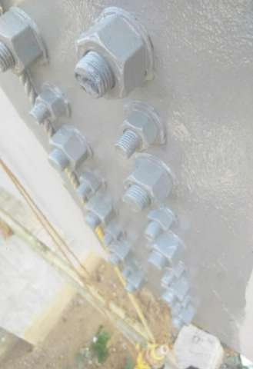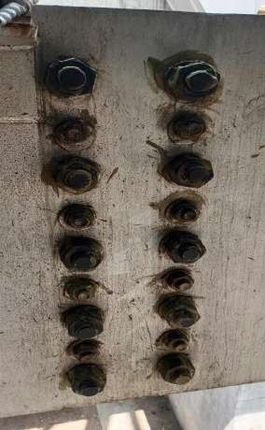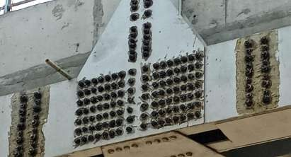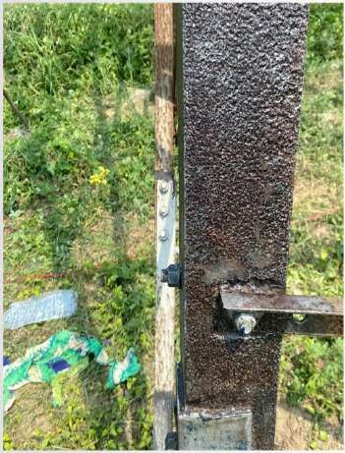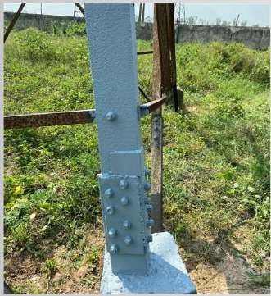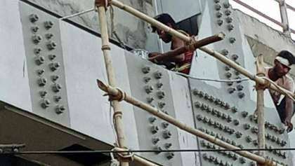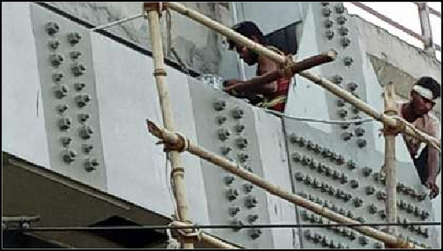

1. **APPLICATION OF KORR - 2 (2ND COAT)**

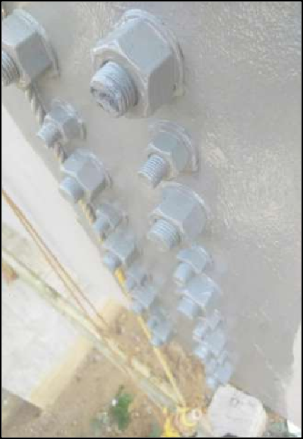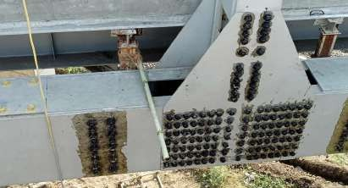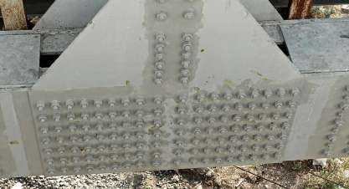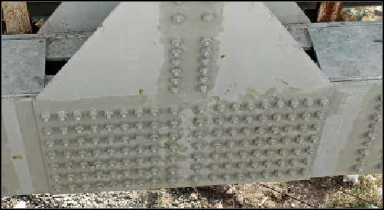



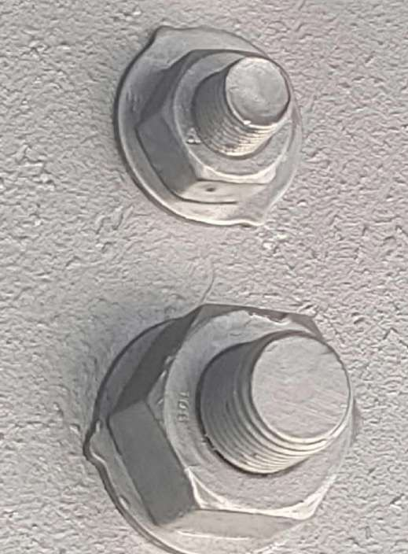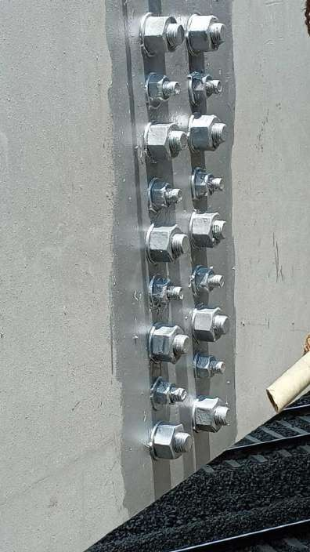

1. **APPLICATION OF KORR – 3 (TOP/FINAL COAT)**

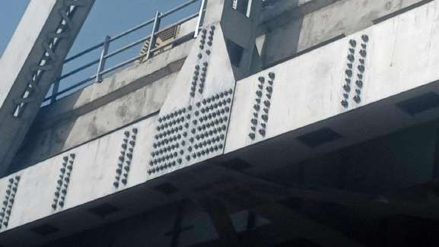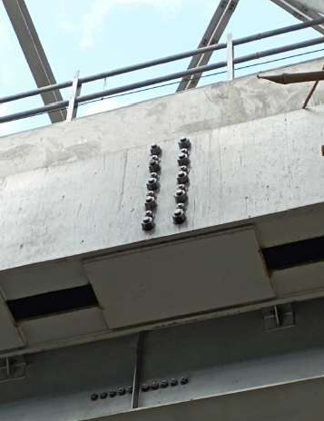

**KORR – 1, 2, 3**

**APPLICATION FOR RAILWAY TRACKS**

# COATING’ S PROCESS

**FLOW**

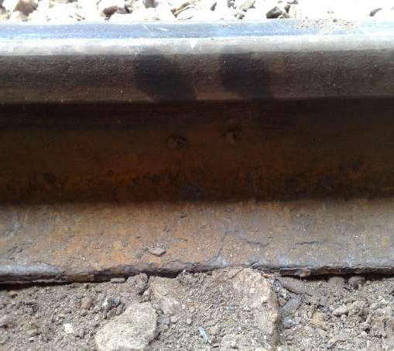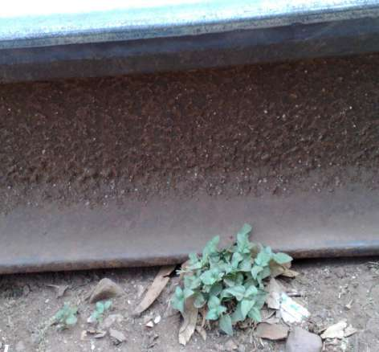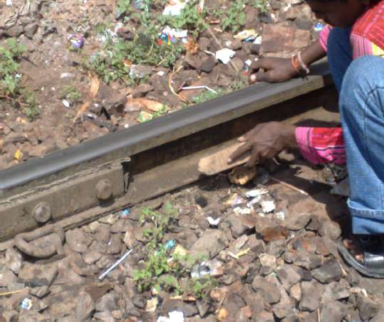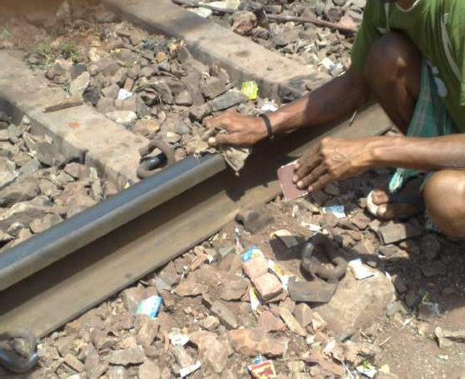

**BEFORE APPLICATION**

#### SURFACE PREPARATION

* 1. Complete remove oil/grease from the metal surface by using petroleum hydrocarbon solvent to IS: 1745.
  2. Prepare the surface by sand or grit blasting to Sa 2-1/2 to IS: 9954 i.e. near white metallic surface.

**REMOVAL OF RUST/PAINT DEPOSITS WITH HAND TOOLS**

#### APPLICATION OF KORR – 1 (1ST COAT)

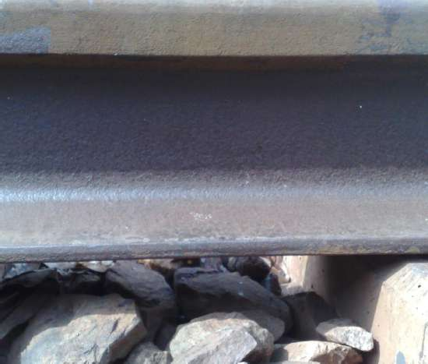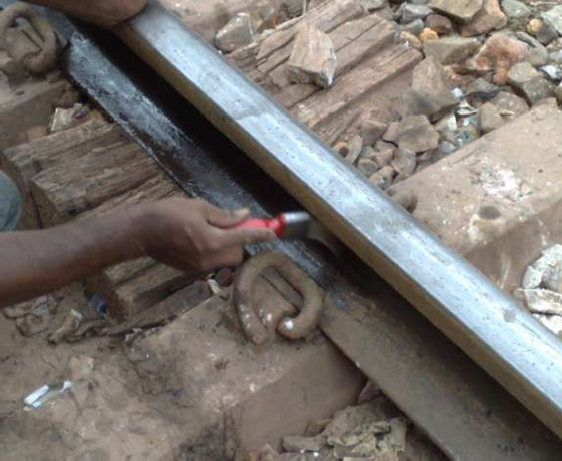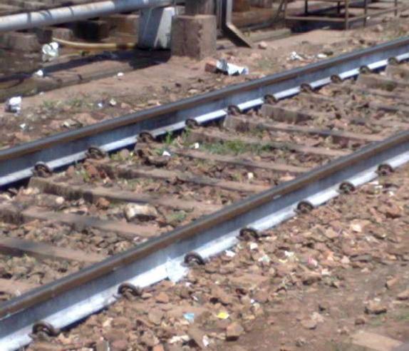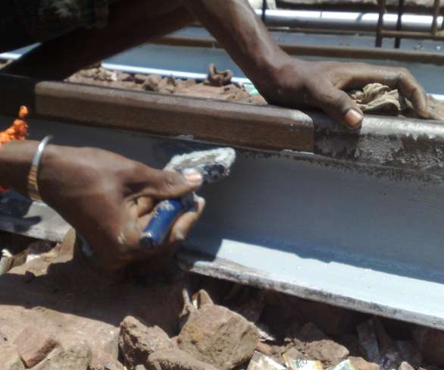

1. **APPLICATION OF KORR – 2 (2ND COAT)**
2. **APPLICATION OF KORR – 3 (TOP/FINAL COAT)**

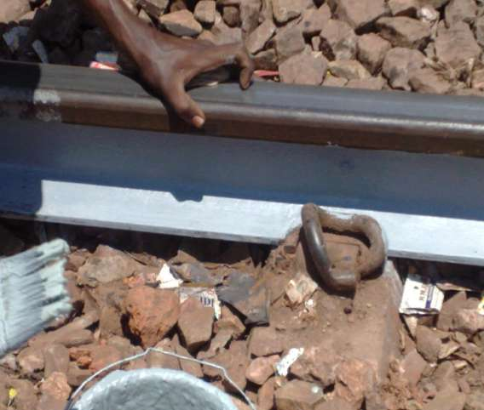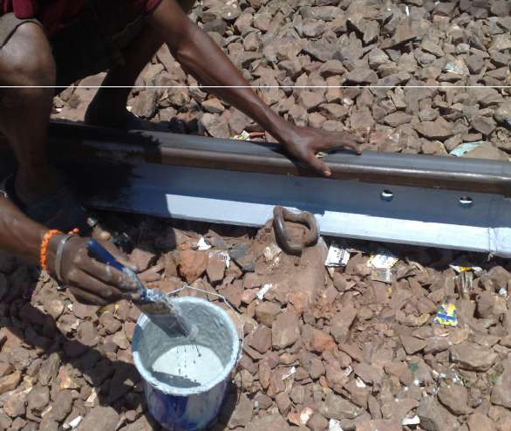

**RAIL SURFACE AFTER COATING’s**

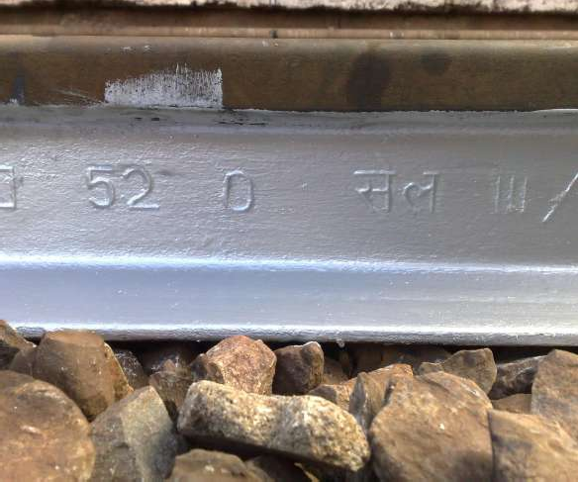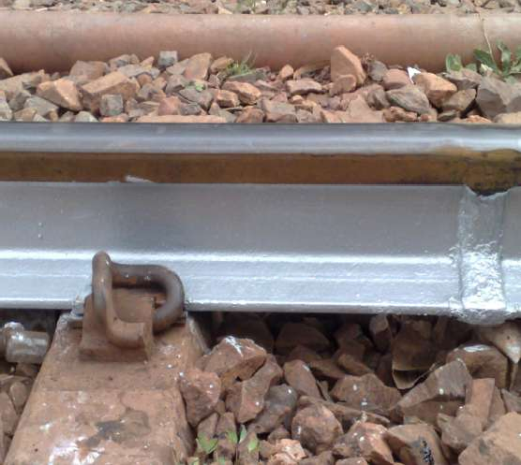

**KORR – 1, 2, 3, 4 APPLICATION FOR**

**RAILWAY JUNCTION /**

**SIGNAL BOXES**

**Special Heat Resistance Coating for Junction Box to reduce inside Temperature by** 𝟕 − 𝟖°**C**

# COATING’ S PROCESS

**FLOW**

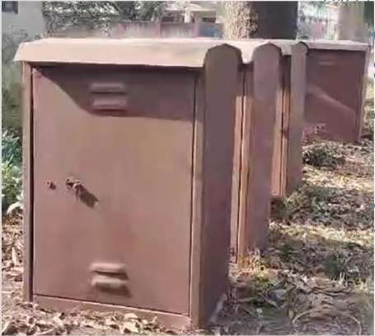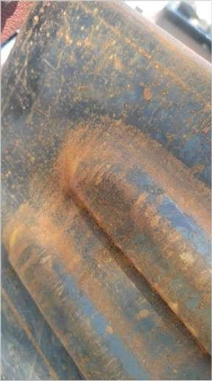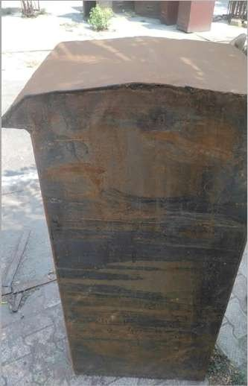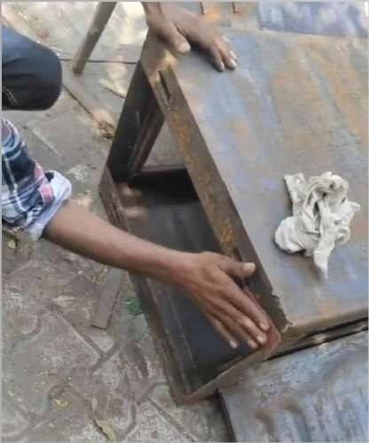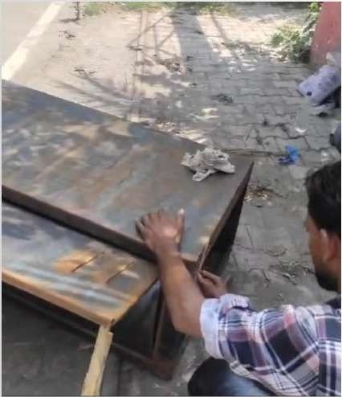

**BEFORE APPLICATION**

#### SURFACE PREPARATION

* 1. Complete remove oil/grease from the metal surface by using petroleum hydrocarbon solvent to IS: 1745.
  2. Prepare the surface by sand or grit blasting to Sa 2-1/2 to IS: 9954 i.e. near white metallic surface.

**REMOVAL OF RUST/PAINT DEPOSITS WITH HAND TOOLS**

#### APPLICATION OF KORR – 1 (1ST COAT)

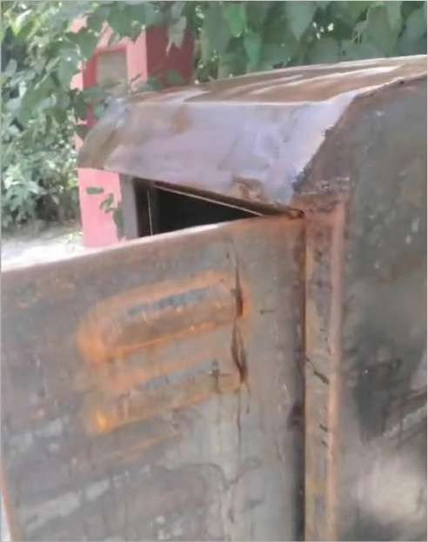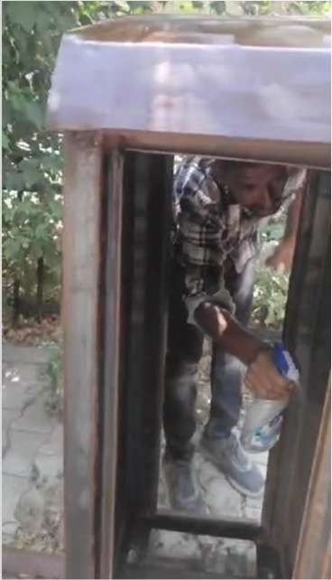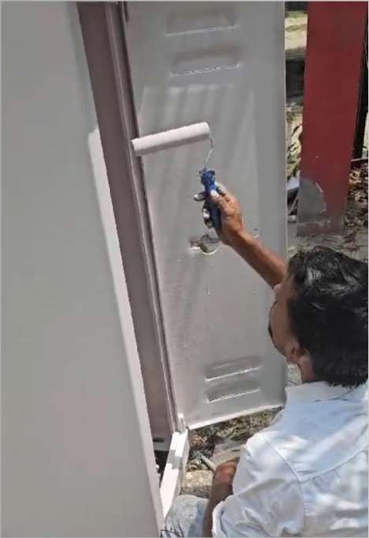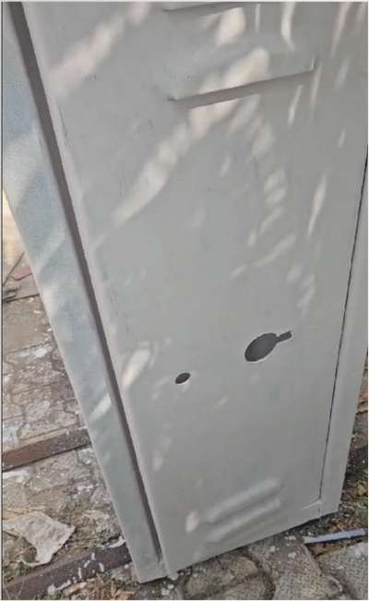

1. **APPLICATION OF KORR – 2 (2ND COAT)**
2. **APPLICATION OF KORR – 3 (TOP/FINAL COAT)**

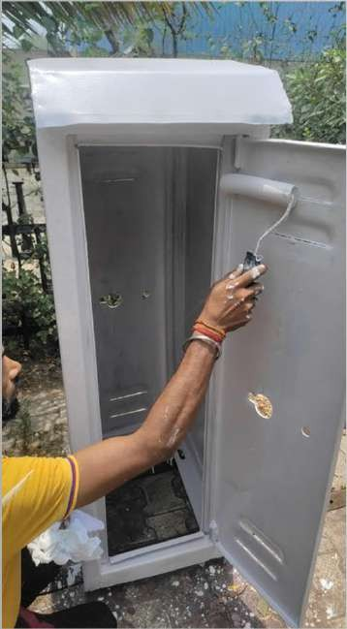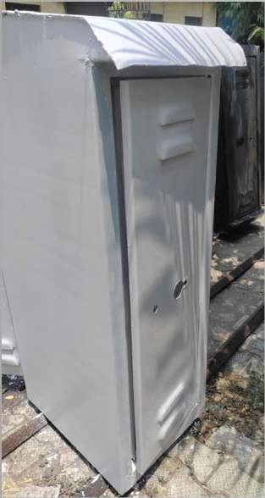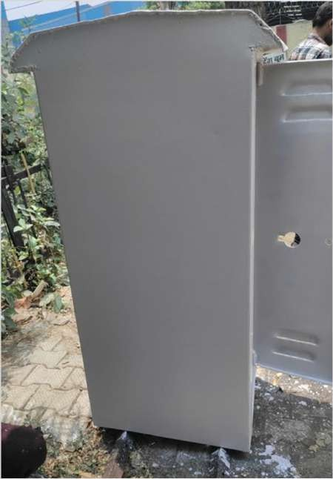

**RAIL SURFACE AFTER COATING’s**

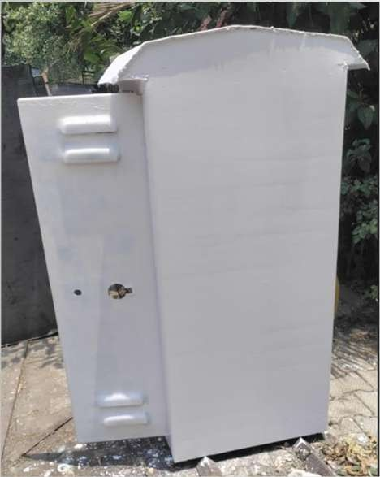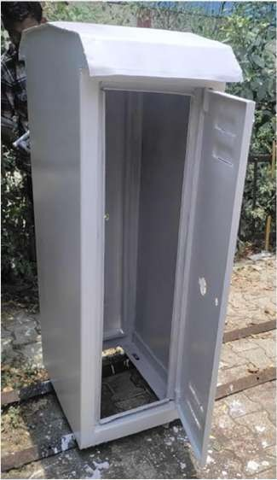

**KORR – 1, 2, 3**

**APPLICATION FOR**

**DI-ELECTRIC FLOOR COATING**

**OR**

**ELECTRIC INSULATION COATING**

**OR**

**PRO ELECTROSHIELD**

##### ELEC TRIC FLOO R I NS ULATI O N C O AT

**I NG**



###### Understanding Electric Insulation Coating

**Electric insulation coating in India, often referred to as dielectric coating, is a non-conductive material applied to electrical components to provide insulation and protection. It assists to preventing electrical leakage, mitigates the risk of electrical shocks, and enhances the durability of electrical equipment.**

###### Product Description

**Pro Electro shield is a composite electric insulation coating designed to impart high electric strength for various electrical applications. Pro Electro-shield is highly hydrophobic in nature and is having excellent water-repellant properties and High chemical resistance. Pro Electro shield film helps to avert the leakage currents, resulting into reduction in contamination flashovers.**

**Product Highlights :**

* **Di Electric strength 77 KV·**
* **Stable up to 80° C.**
* **Excellent resistance to transformer oil.·**
* **Tough and Scratch resistant (excellent puncture resistant),.**
* **Excellent Chemical resistance up to 95% concentrated H2So4.**
* **Drying at Room Temperature.**

**Recommended use :**

**A unique formulation specifically designed for use in electrical safety applications. To be used in front of Electrical control panels, on ceramic, as Insulating coating in front of control panels as replacement of rubber mats, on current carrying conductors & similar live parts to avoid accidents.**

###### Surface preparations :

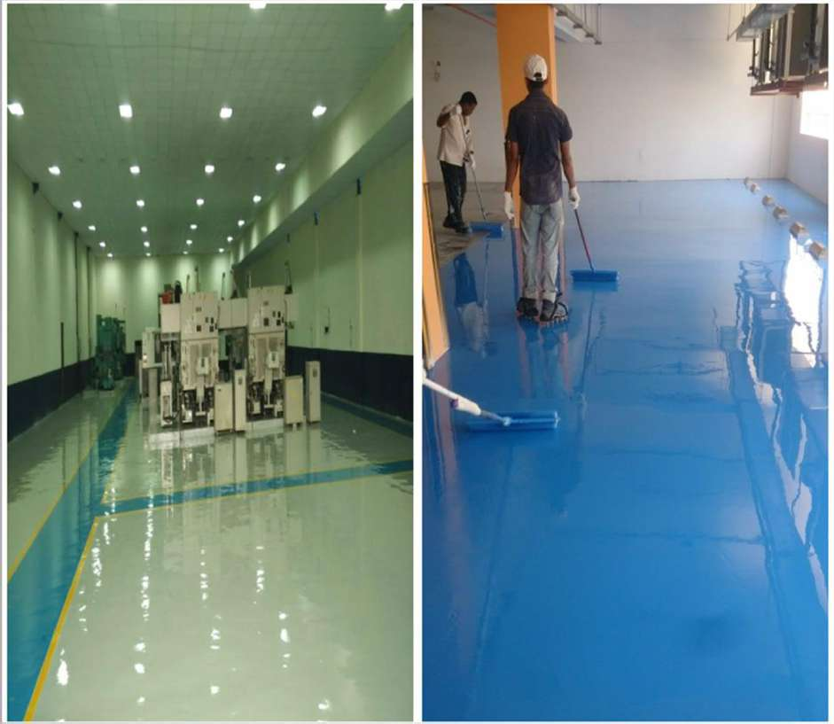

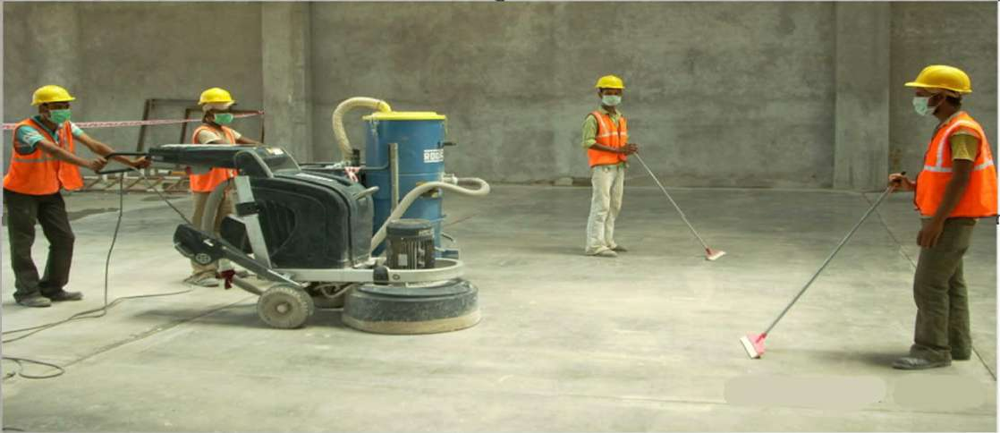**All surfaces should be clean, dry and free from contamination. The surface should be assessed and treated in accordance with ISO 8504.**

◦

###### Surface conditions:

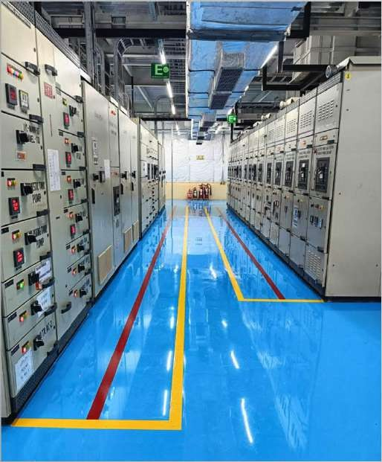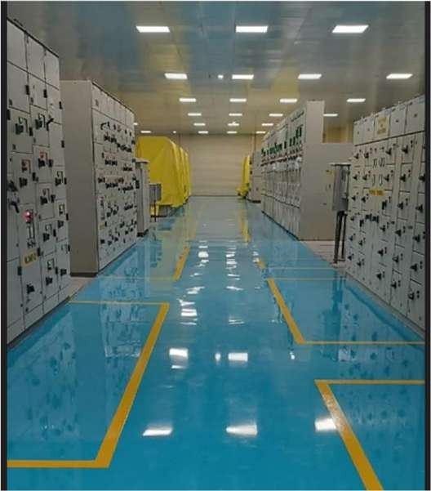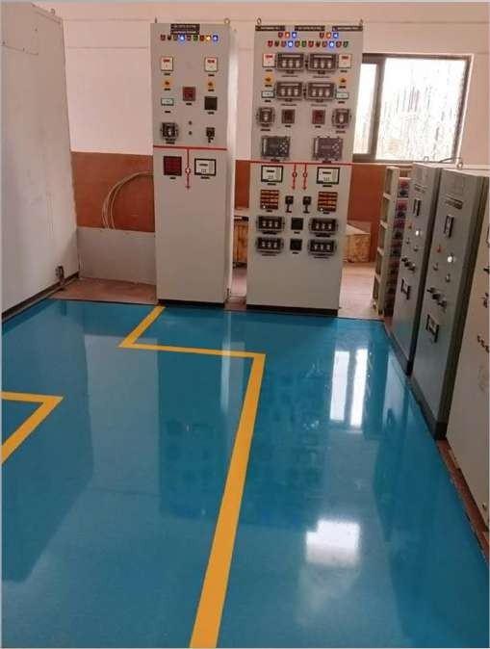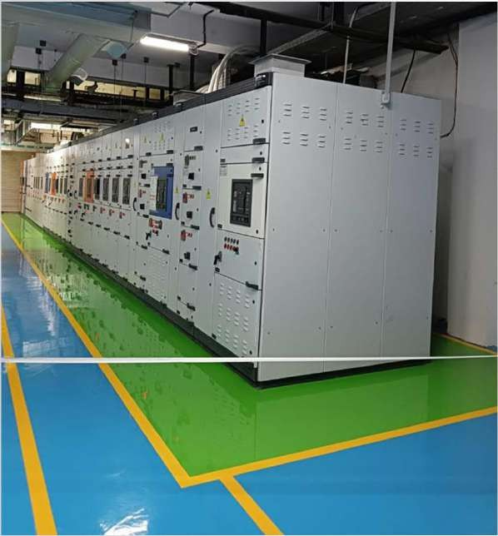

* **Temperature of the substrate - Minimum 3 C above the dew point of the air temperature**
* **Relative humidity - Maximum 80% measured in the vicinity of the substrate**
* **Ventilation - Good ventilation is required in confined areas**

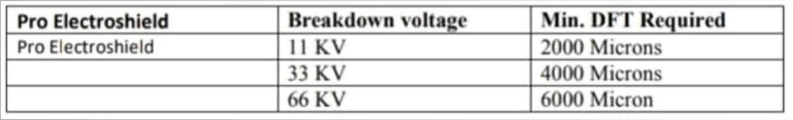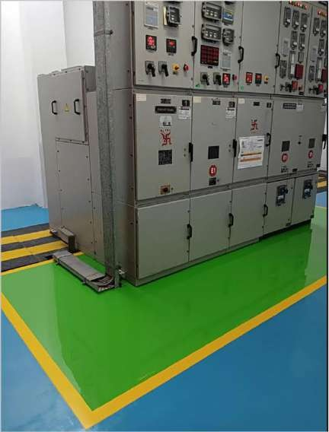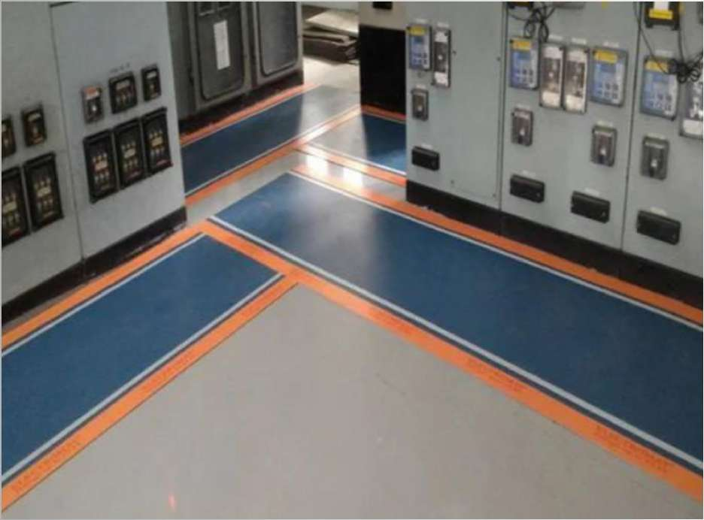

**Film thickness and breakdown voltage :**

### N A BL T E S T RE P O RT S

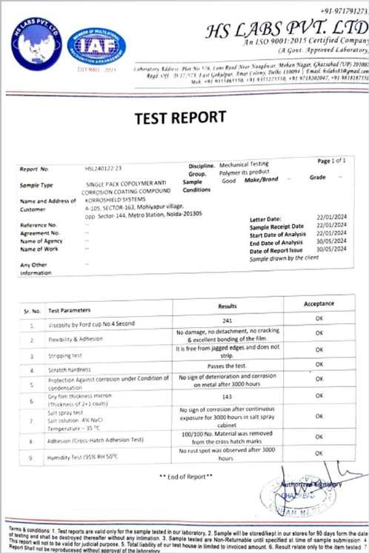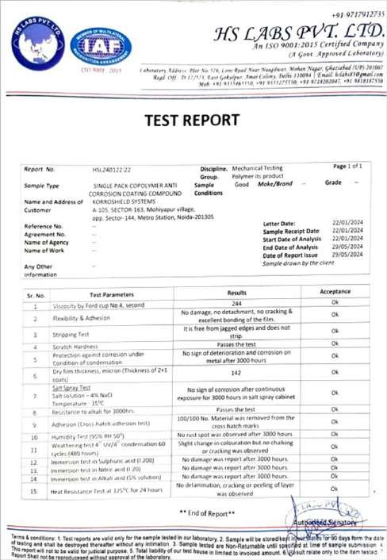

**TES T REPO RTS**

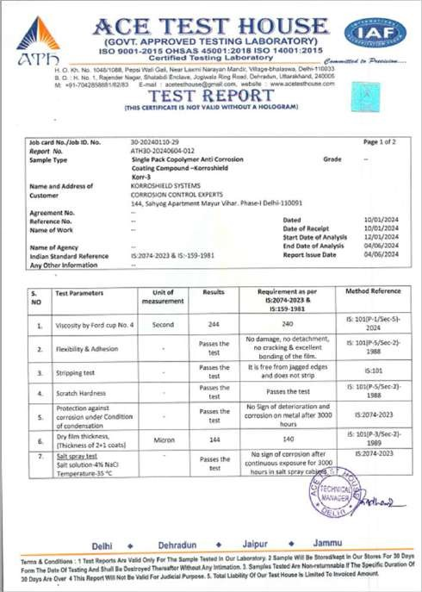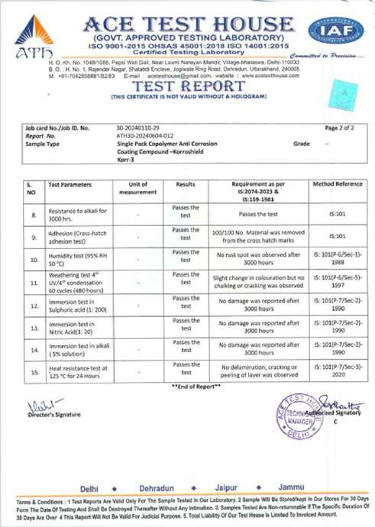

**K O R R - 3**

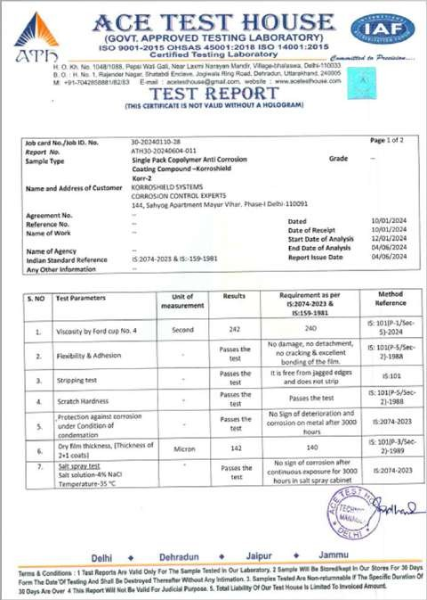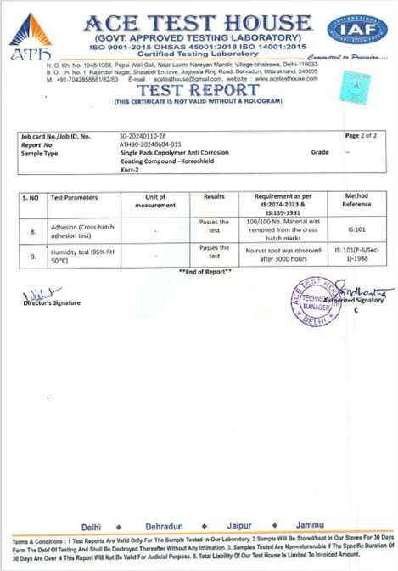

**K O R R - 2**

## OUR GEMSTONE PRODUCTS

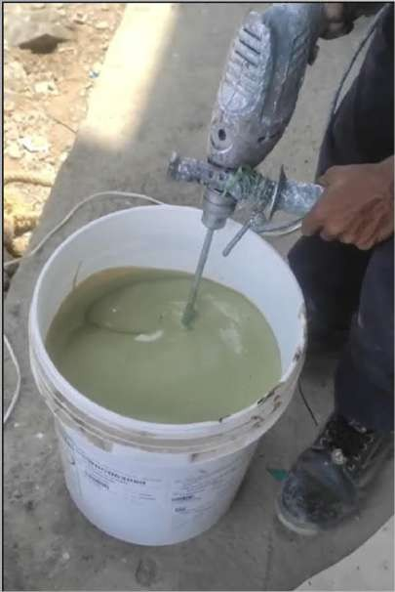

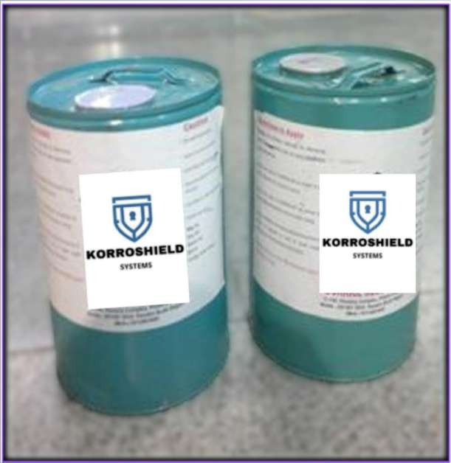**KORR – 1, 2, 3 SYSTEM**

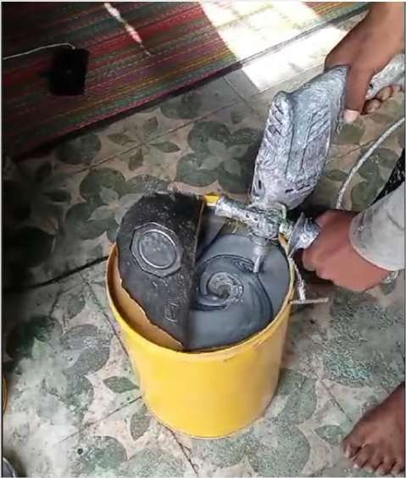

**KO RR - 2**

**KO RR - 3**

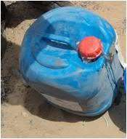

**KO RR - 1**

### A N Y QU E S TI O NS ?



**Mr. Sanjeev Sinha : +91- 9810 0923 06**

**CONTACT US**

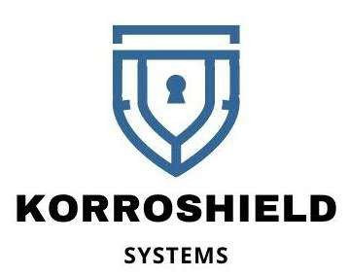



**Office :** 144, Sahyog Apartment, Mayur Vihar, Phase -I, Delhi-110091.

**Works :** A-105, Sector-163, Mohiyapur Village, Opp. Sector-144, Metro Station, Noida-201305 (U.P).

**Email :** [info@korroshield.com](mailto:info@korroshield.com)

**Website :** [**www.korroshield.com**](http://www.korroshield.com/)

**Mr. Amit Malik : +91- 9999 9976 89**